**CAMERA SIMULATOR**

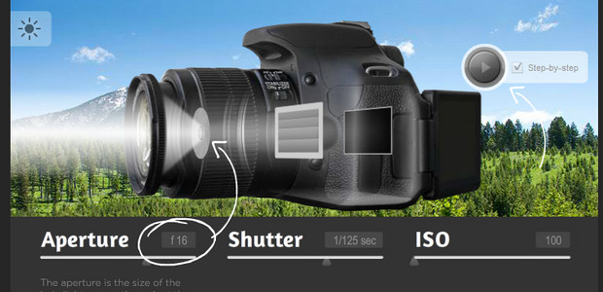

**MAHNOOR AHMED**

**01-133132-121**

**BSE-6A**

**9-APRIL-16**

**What is a Camera Simulator?**

With the **camera simulator** you can try different aperture and shutters to affect a photos light, depth and motion blur. Try also to change the **camera's** light sensitivity by manipulating its ISO value. A higher ISO value gives higher sensitivity to light, which allows faster shutter speeds.

What is Shutter, Aperture, ISO?

* **Aperture**: controls the area over which light can enter your camera
* **Shutter speed**: controls the duration of the exposure
* **ISO speed**: controls the sensitivity of your camera's sensor to a given amount of light

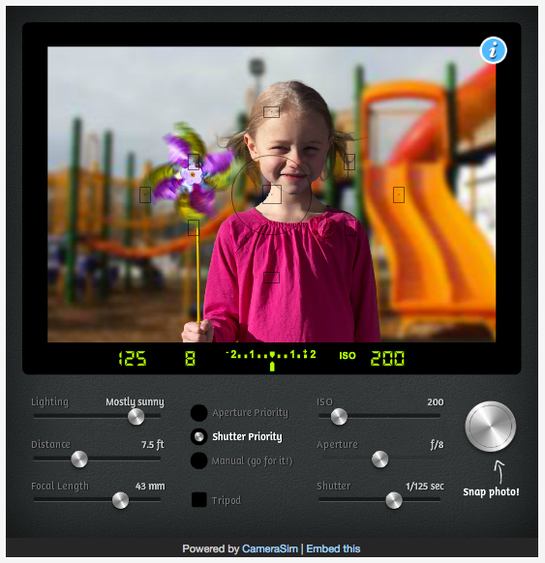

**How My Project Will look like?**

There will be a:

* login form
* simulator form
* contact and feedback form
* some editing filters will also be applied (using bit mapping techniques)
* The gallery is maintained in the database.
* I will use visual studio 2013 professional for making this project.

**Work Flow:**

Some additional features can also be added when I start working on this project.

**References:**

http://camerasim.com/apps/original-camerasim/web/